For immediate release

Millennials and the circular economy

Discussing the benefits of sustainable production for brands at SB16 Sydney

By 2025, 75% of the global workforce will be millennials. Born between 1982 and 2000, this diverse group has been labelled entitled, self-indulgent and selfie-obsessed, but the data shows they are significantly more engaged with sustainability and social justice than previous generations. Seeing beyond financial reward and status, millennials are looking for purpose, sustainability and social impact when it comes to the brands they buy and the brands they work for.

With millennials embracing the decoupling of growth from natural resource consumption, known as the Circular Economy, Accenture recently revealed that it will be an industry worth $4.5 trillion in the next 15 years. And digital is powering the circular revolution just as the steam engine powered the industrial revolution.

This is one of the topics being debated at the inaugural Sustainable Brands conference in Sydney, Australia, 27 – 29 June 2016. Following on from the successful Sustainable Brands conference in San Diego (6 – 9 June) which saw over 200 speakers from companies like Coca-Cola, Ben & Jerry’s, Walmart, Microsoft, Nespresso, Mars, MCDonalds, Google, Nestle, LinkedIn, Dell, PwC, Etsy, Target, Paypal and many more discuss the future of the corporate world.

Speaker at the San Diego conference and continuing on to keynote at the Sydney event, Bert van Son, CEO, MUD Jeans and inventor of the revolutionary Lease A Jeans formula believes a circular economy approach attracts millennials more than the overly utilised principles of the linear economy.

“For decades supply chains and products flowed in one direction: from manufacturing to consumption, ending in landfill, yet we live in a world with limited resources, so it’s time to consider the well-being of the earth and its resources across all industries including fashion.

“Brands need to reduce their dependencies on the world’s scarce natural resources and benefit from the opportunity to generate revenue from waste, to create more innovative, responsive and customer-centric product and services that millennials engage with. It’s not about losing money, it’s about boosting competitiveness in saturated markets.

“I’ve been in the fashion industry for 30 years, and it has many problems. Cotton is one of the worst things we grow on this earth. Every year we grow 24 billion kilos of cotton on 2.5% of our cultivated land and we spray 25% of pesticides and insecticides over it. Consumers want cheap products and brands want fast fashion and maximum revenue so we see many products made by slaves – often children - in very bad conditions. Then, the fast paced nature of fashion sees the world burn garments, which equates to about 10% of the world’s global carbon dioxide. All in all, bad for humans and bad for space ship “earth”.

“At MUD Jeans we are the first and only circular fashion brand making sure our organic and certified cotton jeans come back to us for recycling, by our Lease a Jeans concept. We target the market of millennials; our conscious explorers. I believe in a world without waste and at SB16 Sydney brands will learn that recycling is fun and sustainable too!” concluded Mr van Son.

Bert van Son, CEO, MUD Jeans is a keynote speaker at the Sustainable Brands inaugural Australian conference, 27- 29 June at the Sofitel Sydney Wentworth. Other keynote speakers include Dr Sally Uren, CEO, Forum for the Future, Simon Mainwaring, Founder, We First, Tom Szaky, Founder and CEO, TerraCycle and Jane Caro, social commentator, author, novelist, journalist, broadcaster, columnist and advertising writer.

SB16 Sydney is organised by MCI Australia and supported by host partners Banksia Foundation and Sustainable Business Australia. Strategic partners include the NSW Government and Destination NSW.

Register to attend: http://www.sb16sydney.com/register

-ends-

Notes to editors
- Bert van Son is available for interviews prior to, during and after SB16 Sydney
- All other speakers are available for interviews on request
- Media passes are available – please email laura@zadroagency.com.au for details
- Media partnerships are available – please email laura@zadroagency.com.au for details
- More information about the conference including the full program is available via http://www.sb16sydney.com/

Media contacts
Laura Valentine, Account Manager, Zadro
9212 7867 | 0406 285 077 | laura@zadroagency.com.au

Elizabeth Williams, Group Account Director, Zadro
9212 7867 | elizabeth@zadroagency.com.au

About SB16 Sydney
2016 marks the first year the SB community will gather in Australia! We’ll be building on the HOW NOW theme to prompt leaders to actively apply the know HOW to shift business towards a more flourishing future NOW. Join us as and fully immerse yourself along with over 200 other distinguished leaders for a two jam-packed days of conversation and collaboration at the Sofitel Sydney Wentworth, 27-29 June 2016.

Who attends?
Over 2,200 global and national companies, as well as government officials and NGOs have participated in SB-produced events since 2004. Companies such as: AT&T, BASF, Ben & Jerry’s, Bumblebee, Burt’s Bees, Clorox, Coca Cola, Dell, Disney, Frito Lay, Ford, General Electric, Harrah’s, HP, HSBC, Interface, Johnson & Johnson, Mattel, Office Depot, Pfizer, Marks and Spencer, Molson Coors, P&G, SAP, Starbucks, Starwood Hotels, Target, Toyota, Unilever, Williams-Sonoma, Yahoo! and many more.

About MCI Australia
MCI Australia (www.mci-group.com/australia)
MCI is the world’s largest provider of strategic engagement and activation solutions and has been a key driver of innovation in the meetings, events, association and congress industries since 1987. Through creative live experiences and digitization, globalization, brand enhancement and content strategies, MCI helps multinational companies and international associations enhance organizational performance, grow globally, energize communities and drive business results.

Images

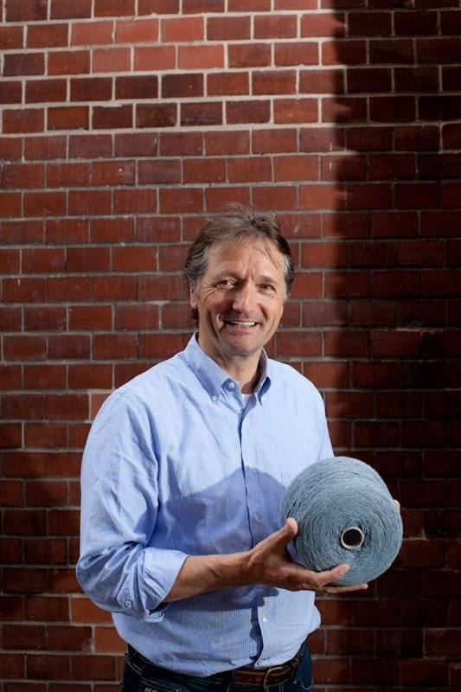

Deloitte Touche Tohmatsu Limited, UK. 2014, 'Big demands and high expectations: Deloitte Millennial survey', viewed 7 June 2016, https://www2.deloitte.com/content/dam/Deloitte/global/Documents/About-Deloitte/gx-dttl-2014-millennial-survey-report.pdf#page=2
Accenture, UK. 2015, ‘Gaining an edge: Growth, Innovation and customer value from the circular economy’, viewed 7 June 2016, https://www.accenture.com/au-en/insight-circular-economy-gaining-edge

